AAS Industries Pizza API User Manual
Alex Litchfield and Adam Lupfer
AAS Industries

🍕

Table of Contents:

Table of Contents:
Overview
Setup Instructions
How To Use
Create Pizza (Staff)
Create Ingredient (Staff)
Create Ingredient Usage (Staff)
Create Promo (Staff)
Read All Pizzas (Customer)
Create Order (Customer)
Create Order Details (Customer)
Add Promo To Order (Customer)
Create Payment (Customer)
Pay For Order (Customer)
Update Order Status (Staff)
Get Order Status (Customer)
Create Review (Customer)
Read Reviews By Customer (Staff)
Conclusion

Overview
The Pizza API is a full API that has been made by AAS Industries with the idea that it can handle many different events that would happen in a pizza shop. The purpose of this API is to handle all of the basic needed tasks to run a pizza shop from the staff side and order from a pizza shop as a customer. Primary functions include a staff member being able to create and update pizzas, ingredients, recipes, and promos, a customer being able to browse the menu and create an order, a staff member being able to view and complete orders, a customer being able to pay for orders, and more.

Setup Instructions
One of the most unique features of the AAS Industries Pizza API is how easy it is to set up. In the “System” router section of the API there is a “Setup Database” function (Figure 1.1). Upon execution of this command the Pizza API will be loaded with all the needed information in order to start running the API (Figure 1.2). Items loaded include a guest customer, a 0 discount promo, 10 ingredients of assorted values, 7 unique pizzas, and 37 ingredient_usage entries (which make up the recipes for each pizza).
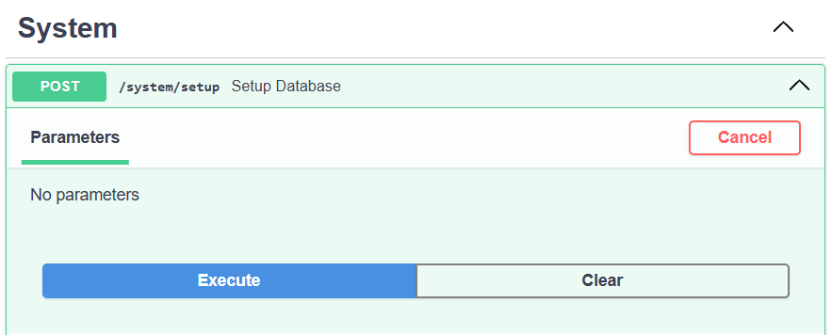
Figure 1.1
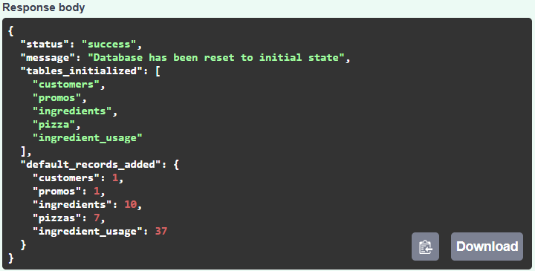
Figure 1.2

How To Use
In this section we will go over how to use the AAS Industries Pizza API. As we go through each endpoint we will do so in a way that we create a narrative in which a user of the Pizza API might need this feature.

Create Pizza (Staff)
A member of the staff has decided that it would be a great idea to add a new pizza to the menu. The idea is a Hawaiian pizza. To do this first the staff member will navigate to the “Create Pizza” function and input the wanted attributes that include name, price, calories, and category (Figure 2.1). Upon execution the staff member will see a 200 code showing the pizza has been added and what id number the pizza has been given (Figure 2.2).
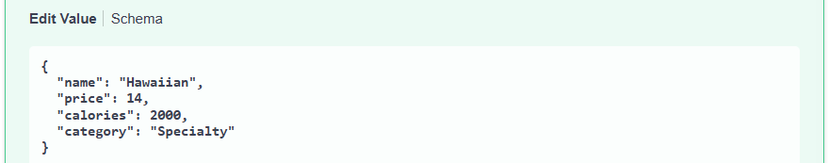
Figure 2.1
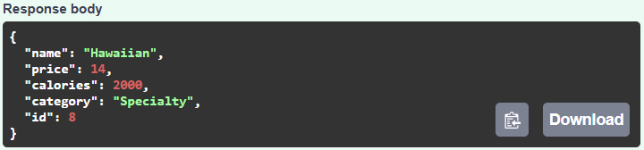
Figure 2.2

Create Ingredient (Staff)
The staff member then realizes that in order to make a Hawaiian pizza he needs pineapple which is not currently in the ingredients database. Thus the staff member will go to the “Create Ingredient” function and input the name and amount of the ingredient that is being added (Figure 3.1). Upon execution the staff member will then get a 200 code saying the ingredient has been added and what id number it has been given (Figure 3.2)
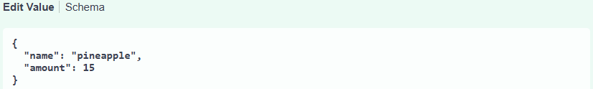
Figure 3.1
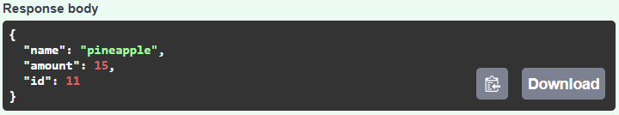
Figure 3.2

Create Ingredient Usage (Staff)
Now that the staff member has added the Hawaiian pizza to the system and has made sure all the ingredients are in the database, the staff member must create the recipe for the pizza. This is done through using the ingredients_usage database. The Hawaiian pizza calls for one crust ingredient to be used. The staff member will add this to the system by adding an ingredient_usage where the pizza_id = 8 ,to represent the Hawaiian pizza, the ingredient_id = 1 ,to represent the crust, and the quantity = 1 to show only one crust is needed (Figure 4.1). Upon execution the staff member will be told it has been added and what id the ingredient_usage has been assigned (Figure 4.2). Since a Hawaiian pizza also has the ingredients of sauce, cheese, ham, and pineapple the staff member will also add an ingredient_usage entry for all of them.
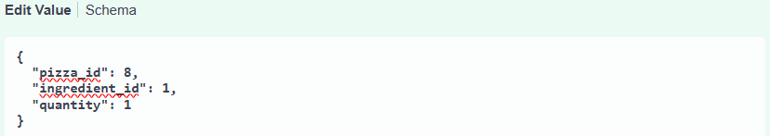
Figure 4.1
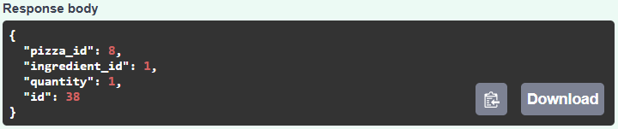
Figure 4.2

Create Promo (Staff)
Now that a Hawaiian pizza has been added to the menu the staff member wants to add a promo to get more people enticed to try it. The staff member will go to the “Create Promo” function and input the promo code 808 (which is also the area code of phones in Hawaii), discount amount of 5 dollars off, and expiration date 12/31/2025 (Figure 5.1). When executed properly the staff member will receive a 200 code saying it has been added to the promo database and at what id (Figure 5.2).
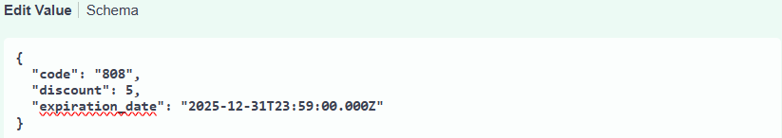
Figure 5.1
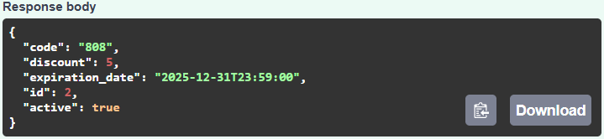
Figure 5.2

Read All Pizzas (Customer)
A customer was told about a new Hawaiian pizza added at this pizza place. The customer goes to the website and wants to view the menu. To do this the customer will navigate to the “Read All Pizzas” function and click execute (Figure 6.1). Upon execution the customer will get a response body that shows all pizzas on the menu along with their price, calories, category, and id number (Figure 6.2).
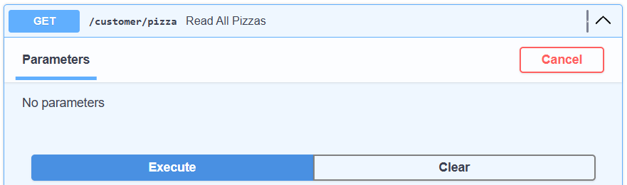
Figure 6.1
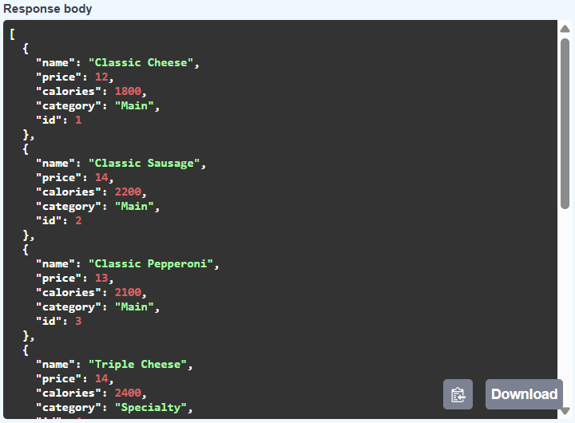
Figure 6.2

Create Order (Customer)
Now that the customer has looked over the menu, the customer is ready to order. To do so the customer will navigate to the “Create Order” function. Since this customer is not a registered customer in the system the customer_id will be set to 1 (the guest id). This customer will also be going in to pick up the order so delivery will be set to false (Figure 7.1). After execution the customer will be told that their order has been created and most importantly will be told what their order_id is, in this case the order_id is set to 1 (Figure 7.2).
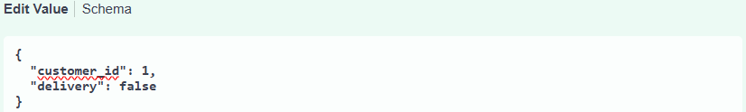
Figure 7.1
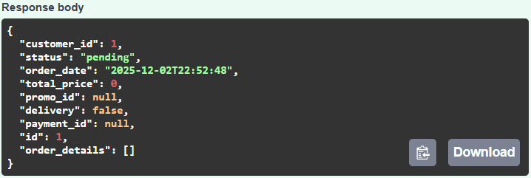
Figure 7.2

Create Order Details (Customer)
After creating the order the customer now wants to add a pizza to the order. To do this the customer will use the “Create Order Details” function. The customer has decided to get 1 Hawaiian pizza so they will input the order_id as 1 (because that is the id for their order), the pizza_id as 8 (because that is the id for the Hawaiian pizza), and since the customer only wants 1 pizza the amount will be set to 1 (Figure 8.1). Upon execution the customer will get a response saying that their order detail has been added to their order along with other details about the pizza selected and the order it belongs to (Figure 8.2).
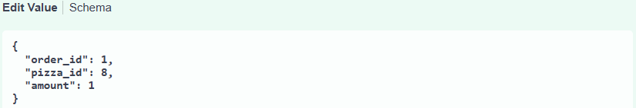
Figure 8.1
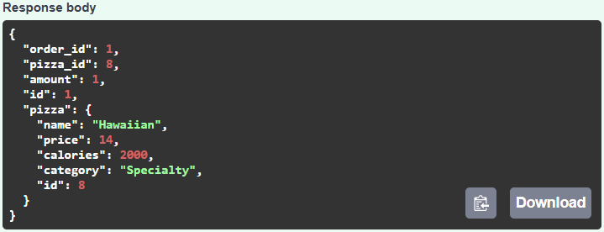
Figure 8.2

Add Promo To Order (Customer)
The customer now has a pizza added to the order, but the customer had heard about the new promo and wants to make sure the $5 discount is applied. To add a promo the customer will navigate to the “Add Promo To Order” function. There the customer will input order_id = 1 since that is the id of the order and promo_code = 808 because that is the code for the promo the customer wants to apply (Figure 9.1). Upon execution the customer will see their order and the pizza(s) associated with the order, but most importantly the customer will see the promo_id has been set and the total_price has been dropped by the discount amount, in this case the promo_id has been set to 2 and the price has gone from 14 to 9 (Figure 9.2).
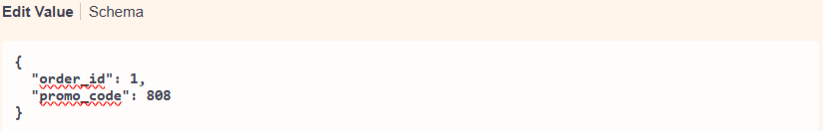
Figure 9.1
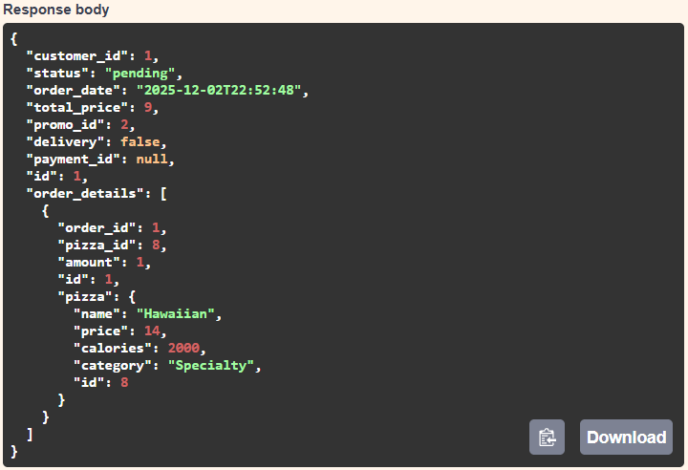
Figure 9.2

Create Payment (Customer)
Now that the pizza and promo has been added the customer is ready to pay for the order. The first step in moving in this direction is to have a payment method set up in the system. The customer will navigate to “Create Payment” and input the payment_type and card_info. Since the customer has a Visa card and the number on the card is 4240 7334 5678 9010 that will be the information inputted (Figure 10.1). Upon execution the customer will get a response saying that the payment has been added and what id number the payment has been given (Figure 10.2).
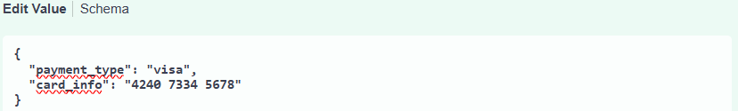
Figure 10.1
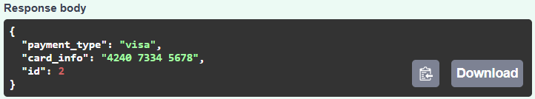
Figure 10.2

Pay For Order (Customer)
Now that the customer has a payment method set up in the database, the customer can go to pay the order. To do so the customer will find the “Pay For Order” function. The customer wants to pay for order_id 1 with the payment_id 2 so that is what will be inserted into the fields specified in the function (Figure 11.1). Upon execution the customer will see the details of the order and all pizzas attached to the order, but most importantly the customer will see that the status has been set to paid and the payment_id has been set to 2 (Figure 11.2).
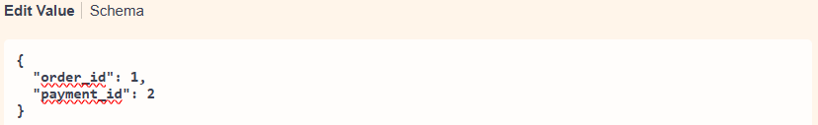
Figure 11.1
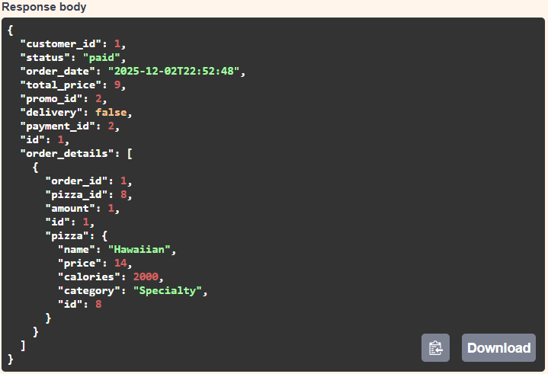
Figure 11.2

Update Order Status (Staff)
Now that the customer has completed and paid for their order the focus shifts to the staff member. Since the order has been paid for, the staff will then create the pizza(s) specified on the order. Once the pizzas have been made the staff member can let the customer know that the pizza(s) are done by setting the order status to complete. To do this the staff member will go to the “Update Order Status” function, input the order_id that is being updated (in this case order 1) and will set the status to = complete (Figure 12.1). Upon execution the order that had been updated along with all the pizzas connected to the order will be displayed, but most notably the order status will then be set to “complete” (Figure 12.2).
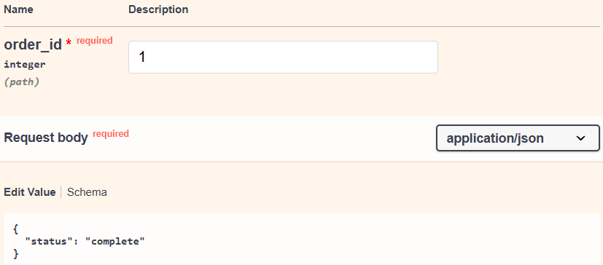
Figure 12.1
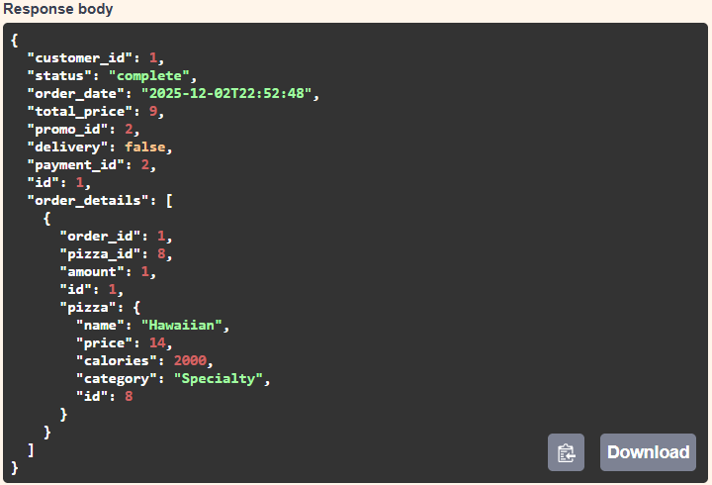
Figure 12.2

Get Order Status (Customer)
Since the customer has already paid for the order, the customer is wondering when the food will be complete and ready to be picked up. In order to find this data the customer will go to the “Get Order Status” function. Since the order the customer has bought is order_id 1 the customer will put that in the parameter field (Figure 13.1). Upon execution the customer will get a response body telling the order status (Figure 13.2). In this case the order is complete and thus is ready to be picked up.
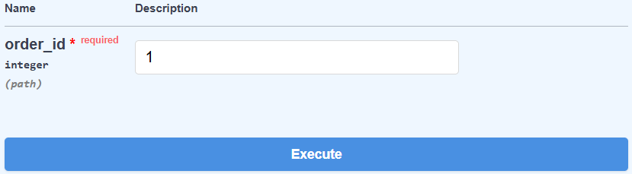
Figure 13.1
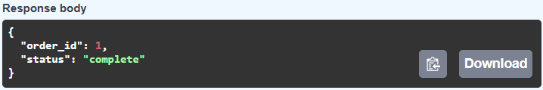
Figure 13.2

Create Review (Customer)
Now that the customer has picked up and eaten the Hawaiian pizza, the customer's life has been forever changed. It was the best Hawaiian pizza the customer has ever had and the customer wants the staff to know. The customer can do this by going to the “Create Review” function. The customer will use the guest customer id of 1, and will give the hawaiian (pizza_id 8) and 10 rating while saying “Best Hawaiian I’ve ever had!!!” (Figure 14.1). Upon execution the customer will see that the review has been added and given the id of 1 (Figure 14.2).
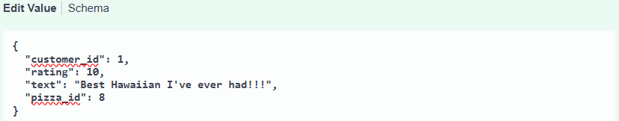
Figure 14.1
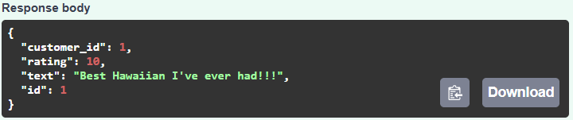
Figure 14.2

Read Reviews By Customer (Staff)
The staff member wants to know if any of his customers have any opinions on the pizza being provided. The staff member can thus go to the “Read Reviews By Customer” function to see what people have said. The staff member wants to see as many reviews as possible so the staff member will look to see what the guests have said (since there are more guests than other customers) so the staff member puts 1 in the customer_id field (Figure 15.1). Upon execution the staff member will see all reviews left by the customer with that id (Figure 15.2). In this case there is one review saying the Hawaiian was the best the customer had ever had.
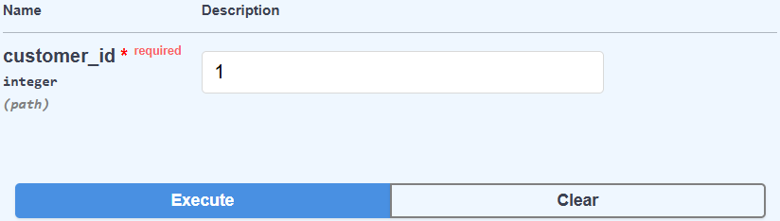
Figure 15.1
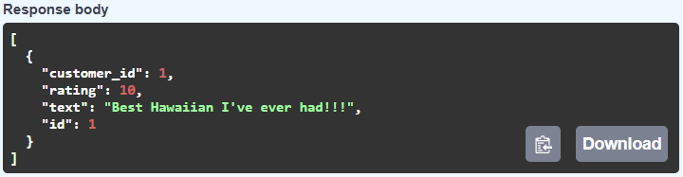
Figure 15.2

Conclusion
The AAS Industries Pizza API has more endpoints and functions that were not fully disgusted here. That being said these are the main endpoints that would be used in the running of a pizza place which is what the goal of the Pizza API is.

